Making your H Drive Available Offline.
- Go to the computer
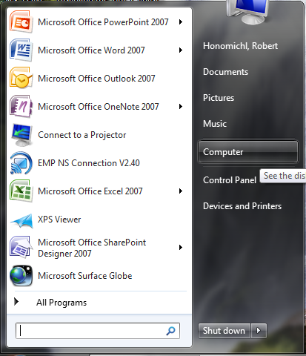
- Right click on your h Drive and choose Always Available Offline. After this it will go through a process. You need to let this go through while you are on the network. 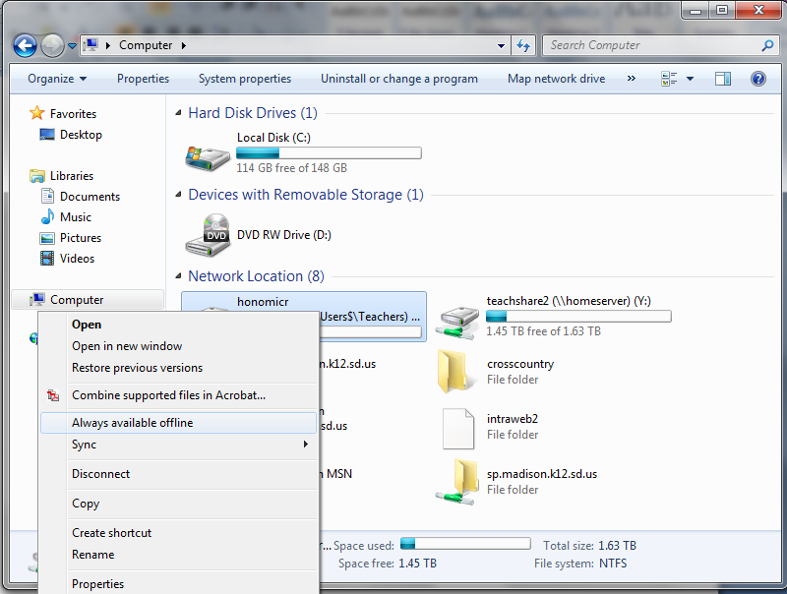
- Then go to your documents. Then Click on Include a folder. Once the next dialog box make sure you select your H drive. Then all your h drive files will appear in your documents and be available both on and off the network. 